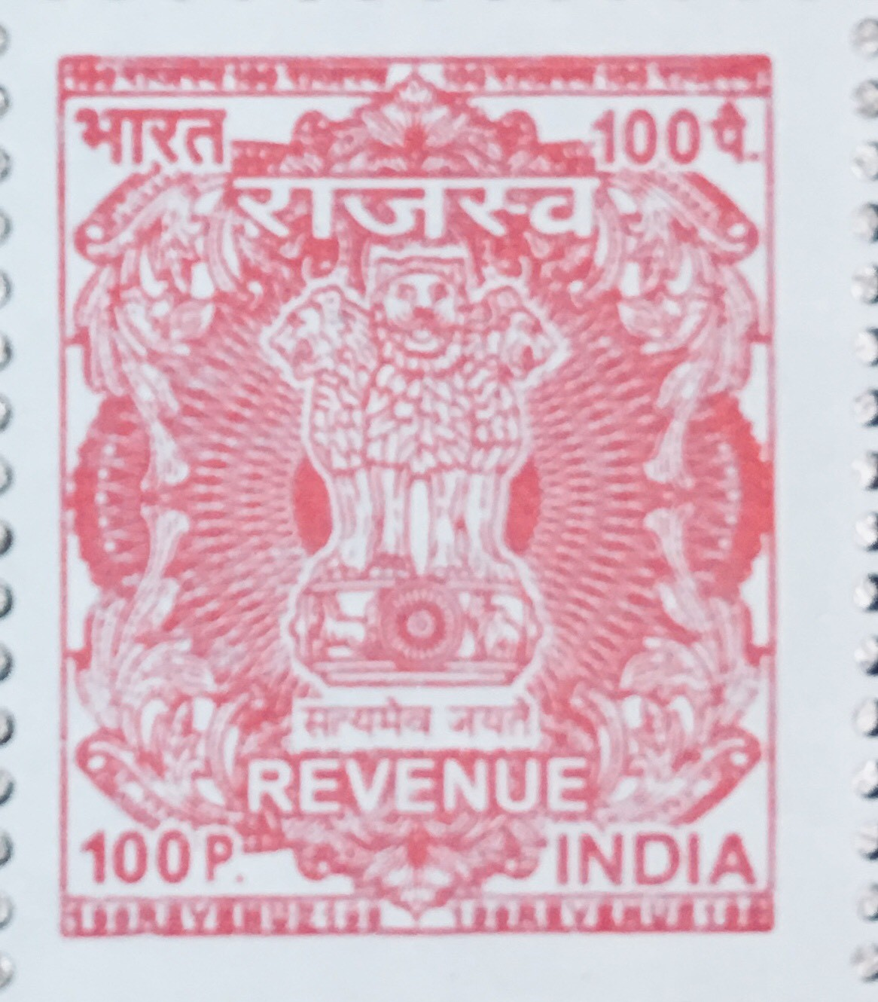



Owner ......**Punithavathy**.............................................................................. Dated ....**05**.... /....**01**.... /....**2023**....

Received with thanks from ......**Harishkumar**........................................................................................ (Tenant)

Address ...... **NO. 360, Nakstra Apartments, Rajiv Gandhi Salai, Indira Nagar, Thoraipakkam**………………….

……**Tamilnadu - 600097**...........................................................................................................................................

The Sum of Rs. ..............**204000**.........................................................................................................................

Monthly Rent Rs. ................**17000**.................. From ........**Apr 2022**........ To …. **Mar 2023**......

Total Rs. ....... **204000**........... Balance Rs. ..........**0**............. Advance Rs. .........**100000**............

(Signature of Property Owner)

Rs. ……**204000**.……/-

Revenue Stamp

RENT RECEIPT

